***OOP Lab 1 Exercise***

***Question # 01***: Write a program that generates the following output using /= and += operators.

**100**

**50**

**52**

**26**

**28**

***Question # 02***: Write a program for multiplication of two matrices.

***Question # 03***: Write a function named "swap_floats" that takes two floating point arguments and interchanges the values that are stored in those arguments. The function should return no value. To take an example,

**if the following code fragment is executed float x = 5.8, y = 0.9;**

**swap_floats (x, y);**

**cout << x << " " << y << endl;**

**then the output will be 0.9 5.8.**

***Question # 04***: Create the equivalent of a four-function calculator. The program should ask the user to enter a number, an operator, and another number. (Use floating point.) It should then carry out the specified arithmetical operation: adding, subtracting, multiplying, or dividing the two numbers. Use a switch statement to select the operation. Finally, display the result.

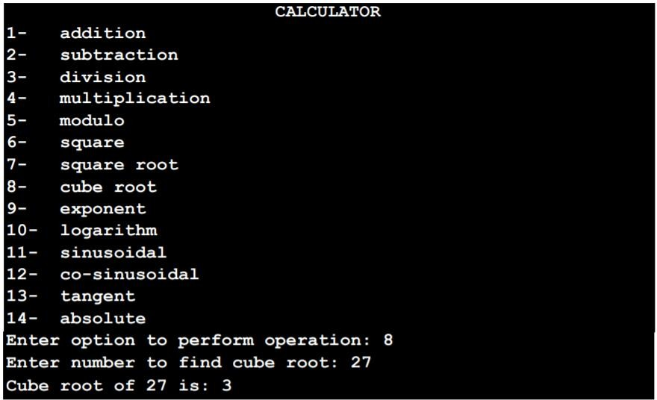

***Question # 05:*** Suppose you give a dinner party for six guests, but your table seats only four. In how many ways can four of the six guests arrange themselves at the table? Any of the six guests can sit in the first chair. Any of the remaining five can sit in the second chair. Any of the remaining four can sit in the third chair, and any of the remaining three can sit in the fourth chair. (The last two will have to stand.) So the number of possible arrangements of six guests in four chairs is 6*5*4*3, which is 360.

Write a program that calculates the number of possible arrangements for any number of guests and any number of chairs. (Assume there will never be fewer guests than chairs.) Don’t let this get too complicated. A simple for loop should do it.

***Question # 06:*** Write a C program to read an amount (integer value) and break the amount into smallest possible number of bank notes. Note: The possible banknotes are 100, 50, 20, 10, 5, 2 and 1.

***Question # 07:*** Using IF and Switch statement, write a program that displays the following menu for the food items available to take order from the customer:

**B= Burger (Rs. 200)**

**F= French Fries (Rs. 50)**

**P= Pizza (Rs. 500)**

**S= Sandwiches (Rs. 150)**

The costumer can order any combination of available food. The program first ask to enter the no of types of snacks i.e. 2, 3 or 4 then it ask to enter the choice i.e. B for Burger and then for quantity. The program should finally display the total charges for the order.

***Question # 08:***Bob's Discount Bolts charges the following prices:

**5 cents per bolt**

**3 cents per nut**

**1 cent per washer**

Write a program that asks the user for the number of bolts, nuts, and washers in their purchase and then calculates and prints out the total. As an added feature, the program checks the order. A correct order must have at least as many nuts as bolts and at least twice as many washers as blots, otherwise the order has an error. For an error the program writes out "Check the Order: too few nuts" or "Check the Order: too few washers" as appropriate. Both error messages are written if the order has both errors. If there are no errors the program writes out "Order is OK."

**Number of bolts: 12**

**Number of nuts: 8**

**Number of washers: 24**

**Check the Order: too few nuts**

**Total cost: 108**